Prerequisites for the Hyperledger Fabric:

Ubuntu LTS 18.04

* Install Go Language.
* Install Docker and Docker Compose.
* Install nodejs.
* Install npm.

Let’s Start:

* As a first step lets update the system: Use the below command
  + sudo apt update
* Install go lang with:
  + sudo apt install golang-go
* To check go version use this command:
  + go version
* Now, install docker with:
  + sudo apt install docker.io
* Docker version can be checked with:
  + docker –v
* Let’s install docker-compose now:
  + sudo apt install docker-compose
* Install nodejs now with:
  + sudo apt install nodejs
* Check node version with command:
  + node –v
* Now install NPM:
  + sudo apt install npm
* After install npm update it with following command:
  + sudo npm install npm@5**.**6.0 **-**g
* Npm is installed and updated, now check the version with command
  + npm –v
* Output version should be **5.6.0.**
* We are ready with our prerequisites lets now install binaries and docker images with following command:
  + curl **-**sSL http:**//**bit**.**ly**/**2ysbOFE **|** bash **-**s 1.4**.**0

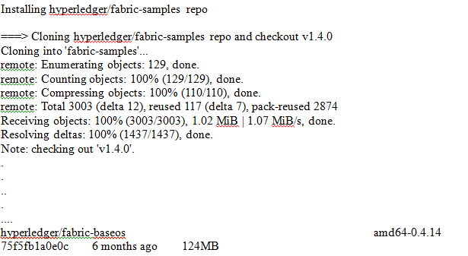

Now we are ready with the prerequisites and you can find **fabric-samples[ samples provided by Hyperledger Fabric]** directory. You can navigate to **fabric-samples,** in the next steps we will be referring **first-network**.